**CONDITIONAL STATEMENT**

* It can be executed based upon the condition
* Another name of conditional statement is decision or selection statement

**If**

**switch**

**Nested if**

**Else if ladder**

**If else**

**IF STATEMENT: FLOW CHART:**

**Syntax:**

**condition**

**if(condition)**

**{**

**//statement true**

**}**

**statement**

**EXAMPLE:**

**import java.util.Scanner;**

**public class Main{**

**public static void main(String[]args)**

**{**

**int age;**

**System.out.println(“enter a age:”);**

**Scanner in = new Scanner(System.in);**

**age=in.nextInt();**

**if(age>=18){  
System.out.println(“you are eligible for vote”);**

**} } }**

**IF ELSE STATEMENT: FLOW CHART:**

**if (condition1) {**

CONDITION

**// condition is true FALSE**

STATEMENT

**}**

**else {**

**// condition is false TRUE**

**}**

STATEMENT

**EXAMPLE:**

**import java.util.Scanner;**

**public class Main{**

**public static void main(String[]args)**

**{**

**int age;**

**System.out.println(“enter a age:”);**

**Scanner in = new Scanner(System.in);**

**age=in.nextInt();**

**if(age>=18){  
System.out.println(“you are eligible for vote”);**

**else{**

**System.out.println(“you are not eligible for vote”);**

**}**

**} } }**

**ELSE IF LADDER:**

**if (condition1) {**

**// condition1 is true**

**} else if (condition2) {**

**//condition2 is true**

**}**

**else {**

**// condition is false**

**}**

**FLOW CHART:**

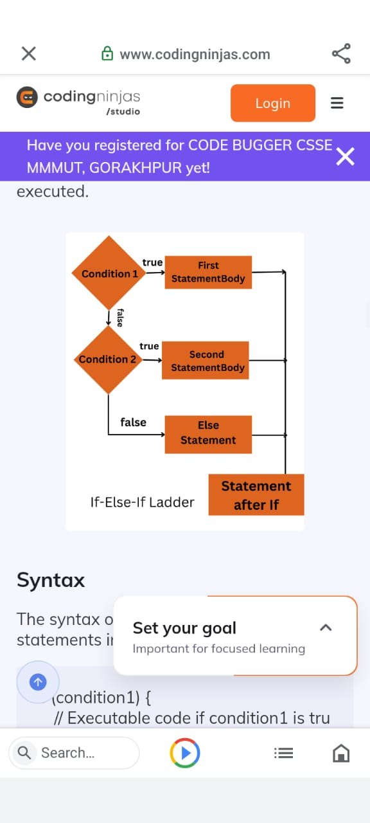

**EXAMPLE:**

**import java.util.*;**

**class sample {**

**public static void main(String[] args) {**

**int i = 3;**

**if (i == 1)**

**System.out.println("January");**

**else if (i == 2)**

**System.out.println("February");**

**else if (i == 3)**

**System.out.println("March");**

**else**

**System.out.println("April");**

**}**

**}**

**NESTED IF:**

**if (condition1) {**

**// Statement1**

**if (condition2) {**

**// Statement 2**

**}**

**}**

**FLOW CHART:**

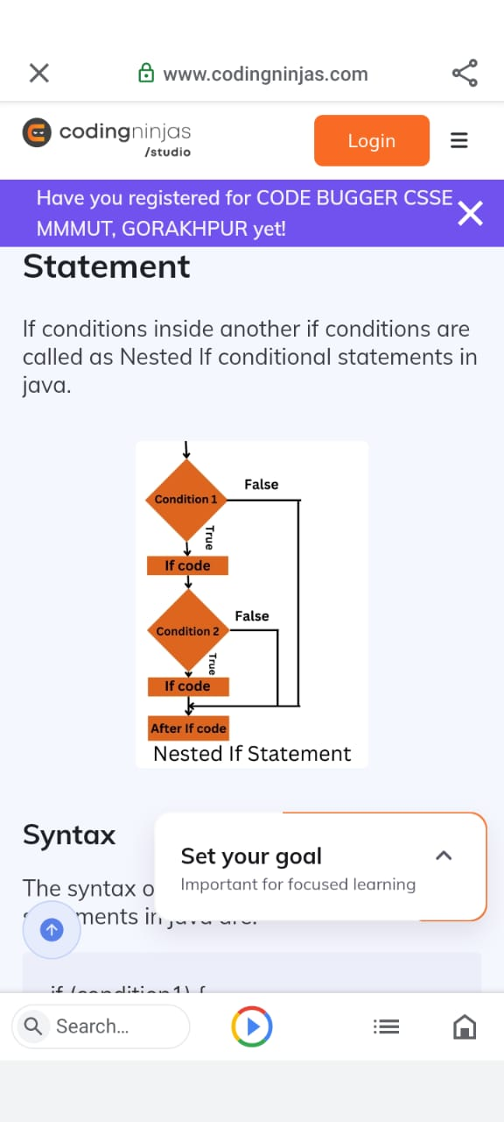

**EXAMPLE:**

**import java.util.*;**

**class sample {**

**public static void main(String[] args) {**

**int i = 10;**

**if (i == 10) {**

**// First if statement**

**if (i < 20)**

**System.out.println("i is smaller than 20");**

**// Nested - if statement**

**if (i < 15)**

**System.out.println("i is smaller than 15 too");**

**else**

**System.out.println("i is greater than 20");**

**}**

**}**

**}**

**SWITCH STATEMENT:**

**switch (Expression) {**

**case value 1:**

**// Statement 1;**

**case value 2:**

**// Statement 2;**

**case value 3:**

**// Statement 3;**

**…………………..**

**Default:**

**// default statement;**

**}**

**EXAMPLE:**

**import java.util.*;**

**class Sample {**

**public static void main(String[] args) {**

**int mon = 2;**

**switch (mon)**

**case 1:**

**System.out.println("January");**

**Break;**

**case 2:**

**System.out.println("February");**

**Break;**

**case 3:**

**System.out.println("March");**

**break;**

**case 4:**

**System.out.println("April");**

**break;**

**case 5:**

**System.out.println("May");**

**break;**

**case 6:**

**System.out.println("June");**

**break;**

**default:**

**System.out.println("Not present in first half month of year");**

**}**

**}**

**}**

**LOOPING STATEMENT**

* **It can be executed block of code as long as condition is reached**

**(it can be executed repeatedly satisfying the condition)**

* **Reduce the errors**

Exit control loop

Entry control loop

**ENTRY CONTROL LOOP:**

* **First it will check the condition , after that only execute the loop**

1. **For loop**
2. **While loop**

**EXIT CONTROL LOOP:**

* **It executed first if the condition is true or false no considered , after only checks the condition**

1. **Do while**

**In java do while loop is not used**

**FOR LOOP:**

**Syntax:**

**for(initialization;condition;increament/decrement)**

**{ //statement**

**}**

**EXAMPLE:**

**for (int i = 0; i < 5; i++) {**

**System.out.println(i);**

**}**

**WHILE LOOP:**

**Syntax:**

**While(condition)**

**{ // statement**

**}**

**EXAMPLE:**

**int i = 0;**

**while (i < 5) {**

**System.out.println(i);**

**i++ }**

**JUMP STATEMENT:**

* **It can be jumps control into one statement to another statement**

**break**

**continue**

**BREAK:**

* **It is used to jump out of the loop (mainly used in switch case)**

**EXAMPLE:**

**for (int i = 0; i < 10; i++) {**

**if (i == 4) {**

**break;**

**}**

**System.out.println(i);**

**}**

**CONTINUE:**

* **It can be skip the particular condition given to the program, after it will execute**

**EXAMPLE:**

**for (int i = 0; i < 10; i++) {**

**if (i == 4) {**

**continue;**

**}**

**System.out.println(i);**

**}**